Azure CLI

Logging in
- Logging in with azure cli: az login
- If looging in using ‘az login’ doesn’t work then I can do this:
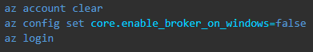

Installation
- When installing cli using winget it is downloading an installer in the C:\Users\mbulk\AppData\Local\Temp\WinGet\Microsoft.AzureCLI.2.71.0. I need to go there and click on it in order to install it. I think that it will be easier to use another option for installing.

Service principal
- If I create a Service Principal without providing its name then it gets assigned the defaul name of format ‘azure-cli-yyyy-mm-dd’ where yyyy-mm-dd is date of creation.

